**How to Download Purple Air Data and Interpret Data**

1. Go to the Purple Air website: <https://www2.purpleair.com/>

Click on View the Map to get to the Purple Air Map. Or you can click on the link below as well.

Map: <https://www.purpleair.com/map?opt=1/mAQI/a10/cC0#4.58/34.72/-111.09>

2. Select a sensor location and click on it.

3. Go to Map Data Layer. The Map Data Layer can be found on the lower left hand side of the map where you will see the color-coded US EPA PM2.5 Air Quality Index as default. Under conversion, select US EPA conversion factor/correction equation.

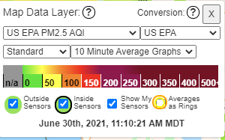

4. Next, navigate to the right hand side of the screen and click on the download icon which will take you to the **Sensor Data Download Tool** website.



The Sensor Data Download tool will allow you to download data from the sensor’s Channel A and Channel B measurements. It will also allow you to view Primary data and Secondary data. Primary Data is where you will find PM (PM1, PM2.5, PM10) sample values as well as Temperature and Relative Humidity sample values. **Keep in mind that CF-1 values correspond to correction factor for indoor measurements and ATM corresponds to atmospheric or outdoor measurements in units of micrograms per cubic meter (µg/m3) of air**. Secondary Data is where you will find particle counts in units of microns (micrometer) per deciliter of air as well as outdoor measurements for PM1 and PM10 in units of µg/m3.

The UptimeMinutes column tells you how long the sensor has been in operation and the RSSI_dbm corresponds to “Received Signal Strength Indicator.” RSSI is a measurement of how well your device can hear a signal from an access point or router. It’s a value that is useful for determining if you have enough signal to get a good wireless connection. Since RSSI varies greatly a more standardized, absolute measure of signal strength is measured in decibels, or dBm on a logarithmic scale. There’s a lot of math we could get into, but basically, the closer to 0 dBm, the better the signal is. The dBm unit, which means decibels relative to the reference power 1 mW. For example, a power of 10 µW = 0.01 mW corresponds to -20 dBm (= 20dB less than 1 mW).

5. To begin downloading data from the Sensor Data Download Tool, first select your Start and End date. Then you want to select your averaging intervals either 10 minute, 15 minute, 30 minute, 60 minute, up to 1440 minutes which is a 24-hour average.

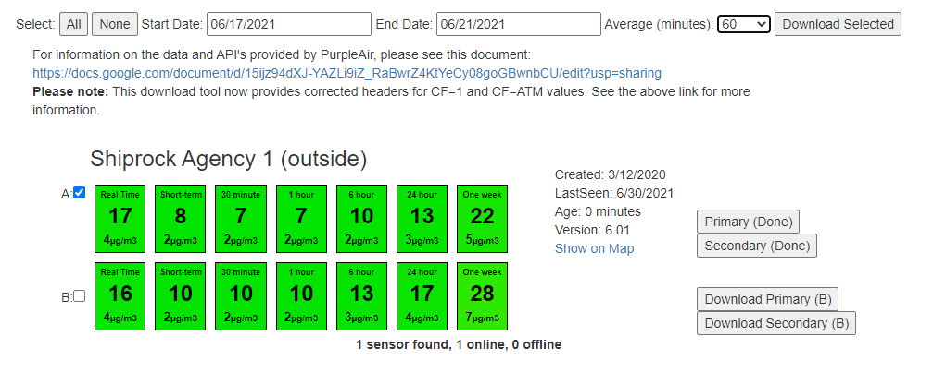

6. In the example above, the date range begins 6/17/21 and ends 6/21/21. The average interval is 60 minutes, which is basically 1-hour averages.

7. Next, you want to select which channel to report data into a .CSV download file. You can select a single Channel and both Primary and Secondary data. Or you can select All which will give you data from both Channel A and B to include both Primary and Secondary data. As you can see in the picture above, for this example, Channel A is selected to report both Primary and Secondary data.

8. A *.CSV file containing the data will be generated in the lower left hand side of the web brower and you should be able to click on the file and open it.



9. Click on the up arrow on the file and open the file to view the data. Data should look like this.

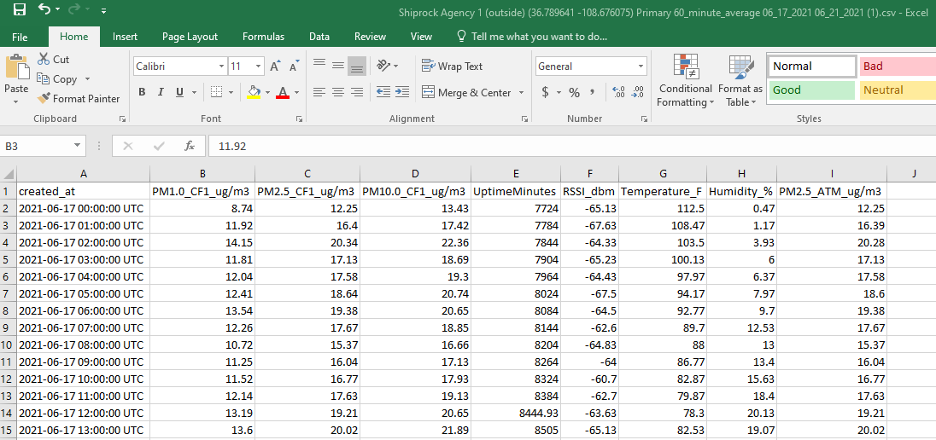

10. As you can see, the time stamp is in Coordinated Universal Time or UTC time. So one way to correct the time stamp to your time zone is to first copy the data in the *.CSV file and paste it into a Notepad file. Basically, creating a text file of the data (see below).

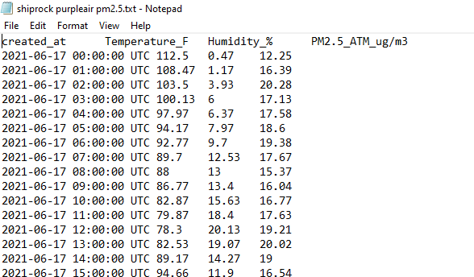

UTC time is the world time standard that regulates clocks and time. It is commonly used by the scientific community in many technical fields. For example, meteorologists, the aviation industry use this time, and it is used to synchronize time across internet networks.

11. Name and save the Notepad file and open an Excel worksheet. Click on **Data** on the top tool menu and select **From Text**. Then navigate to your Notepad file and click on **Import**.

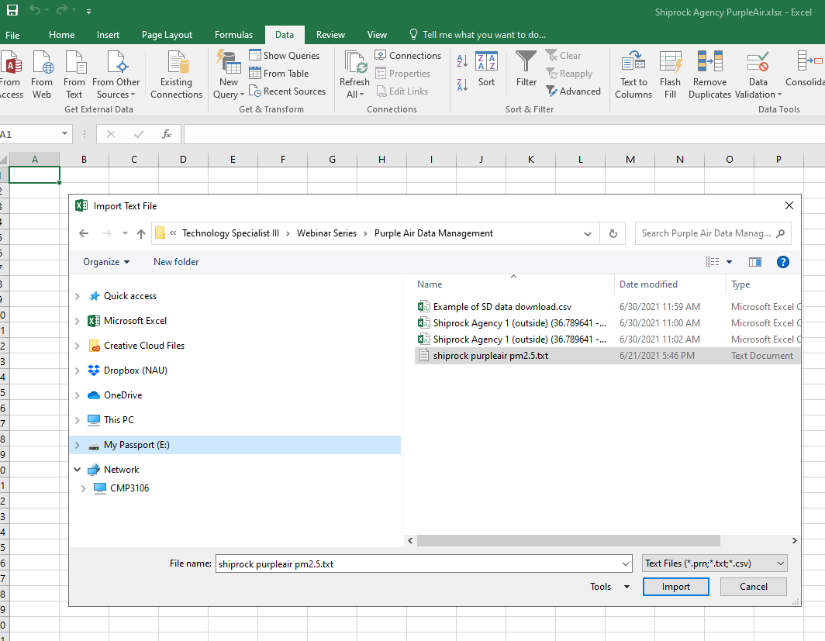

12. The Import Wizard will then open up. You will then select **Delimiters** as the file type that best describes your data. Start import on row cell 1, which corresponds to cell A1, then click on Next.

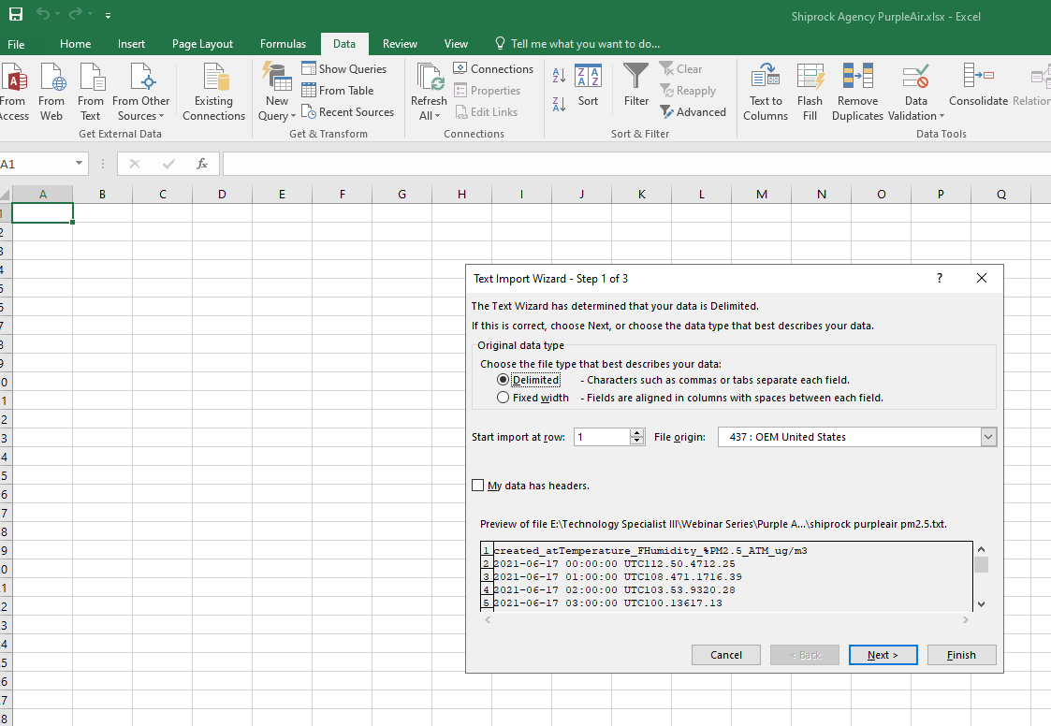

\

13. Then check the box next to **Space**. You should see lines separating the data. Click on Next.

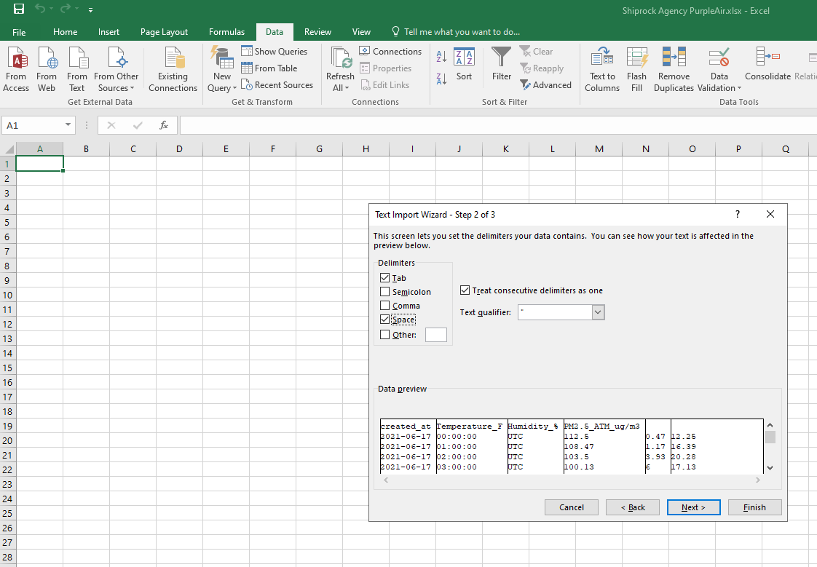

Essentially, we want to use the **space delimiter** to import the data from the Notepad file into the Excel worksheet.

14. Within the Import Wizard, the first column should be your date column. Set the **Column Data Format** for this columnto **Date** and select **YMD** (YearMonthDay) from the drop down list, then click on Finish.

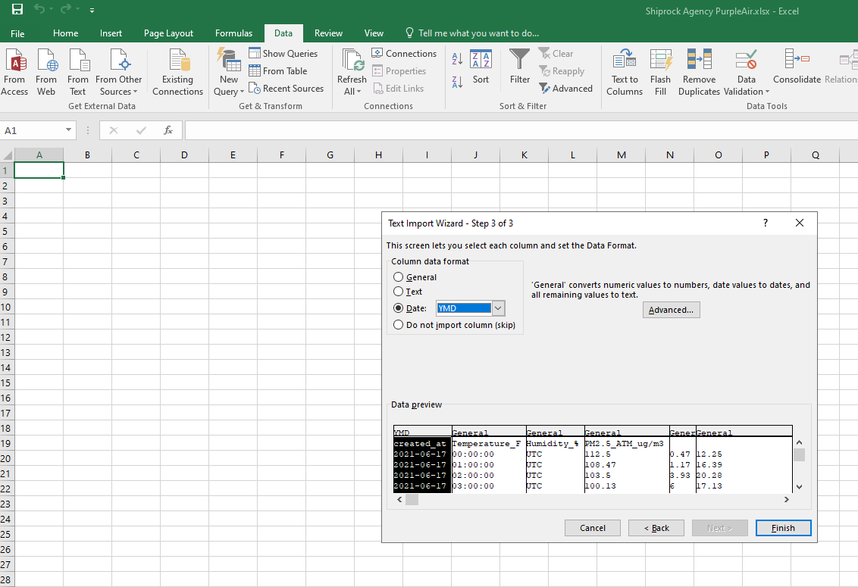

15. The data should now be imported into your Excel worksheet and look similar to what you see below. Notice the column headers. You will need to cut and paste the Temperature_F, Humidity %, PM2.5 ATM µg/m3 (column headers) and paste them under column D, E, and F so they match the data.

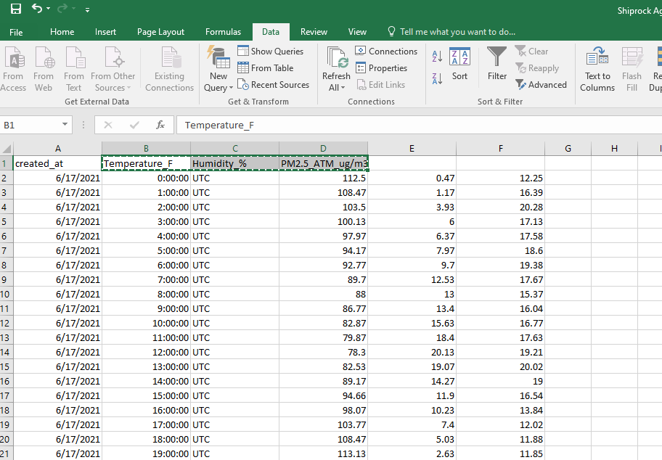

16. You should now have data that looks similar to the format below. You will then remove the column headers for column A and B and replace with Date and Time. Next, you will delete the word “UTC” in column C. This is where we will replace UTC with the corrected time stamp.

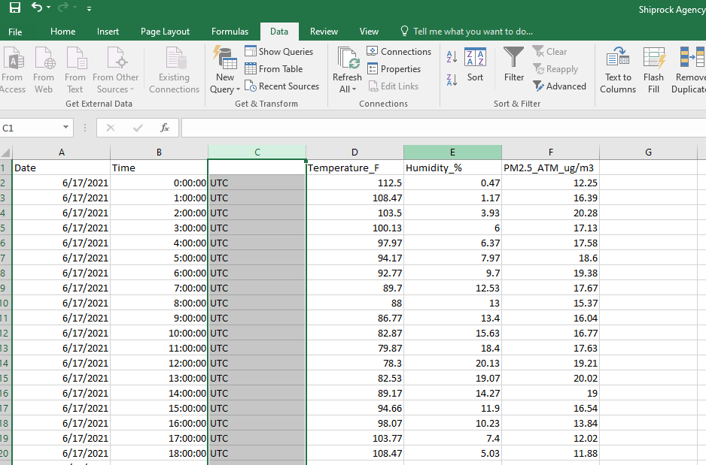

17. For this example, the Purple Air sensor is located in Mountain Daylight Time (MDT) zone, so UTC is 6 hours ahead of MDT. I will simply subtract 6 hours from the 24 hour UTC clock, which would give me 18:00 on the 24 hour clock or 6:00 pm MDT (standard time). Excel recognizes patterns so you can simply type in a few hours, and then left click mouse and hold/drag to highlight the hours. While highlighted hover your mouse over the lower corner of the highlighted area. You should see a small black cross appear. Once the cross appears, double left click on your mouse to autofill the column with the time.

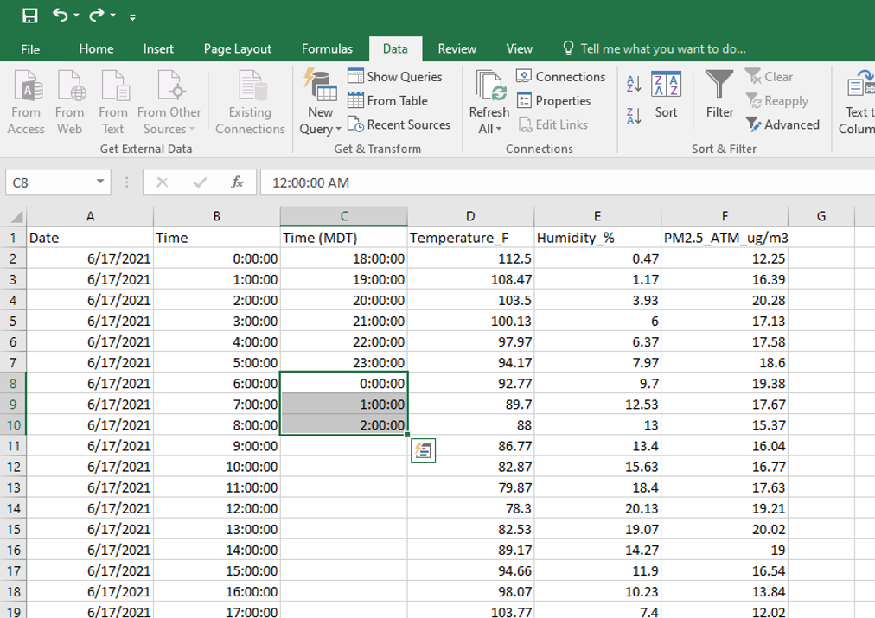

To find what your time zone is in UTC and vice versa, here is a link to a UTC converter: <https://savvytime.com/converter/utc-to-pdt>

To convert 24 hour time to standard time and vice versa, see link below: <https://www.calculatehours.com/Military_Time_Converter.html>

18. You can remove the original UTC time and replace with your time zone. Also be sure to update the date since the time went back 6 hours this puts the date/time stamp into the prior day which would be 6/16/2021 (see yellow highlight).

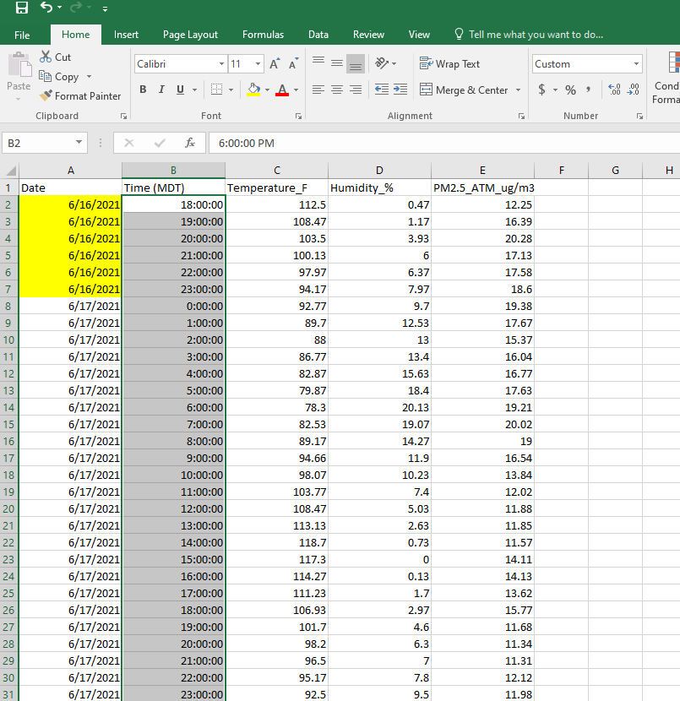

19. You can then now highlight all the data and go to the top tool menu bar and select **Insert** and **Recommended Charts** to chart the data. For this example, I selected the first recommended chart.

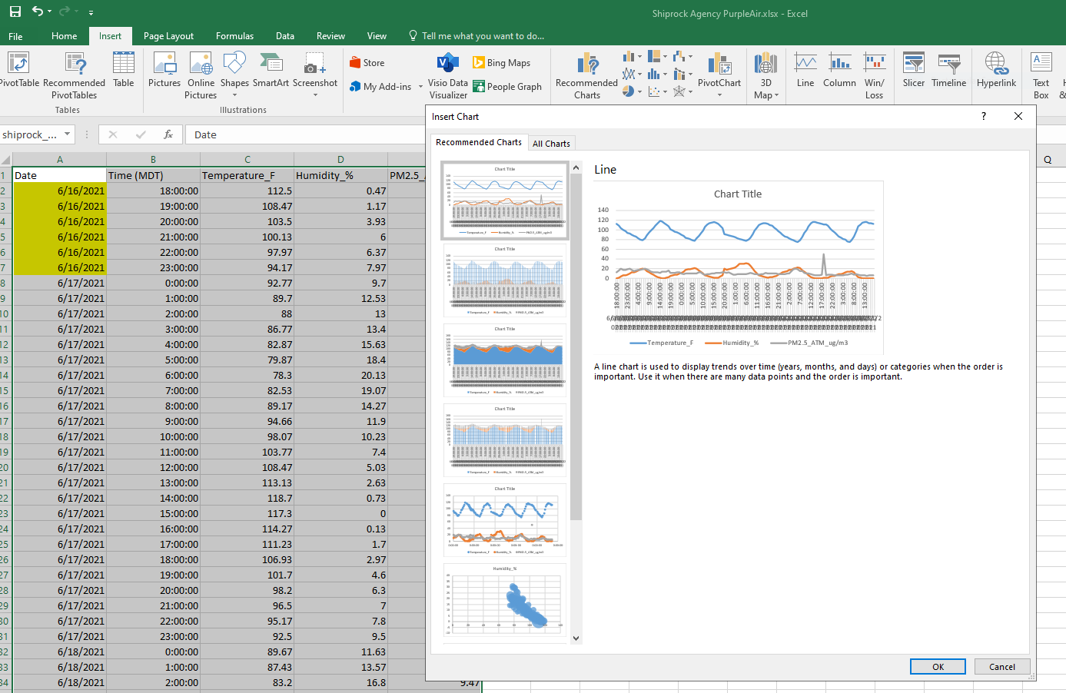

20. You should now see the chart in your Excel worksheet. Notice the Temperature is plotted high on the Y-axis. You can fix this by plotting the Temperature on the secondary Y-axis. First click on the Temperature data on the chart and right click your mouse to select **Format Data Series**.

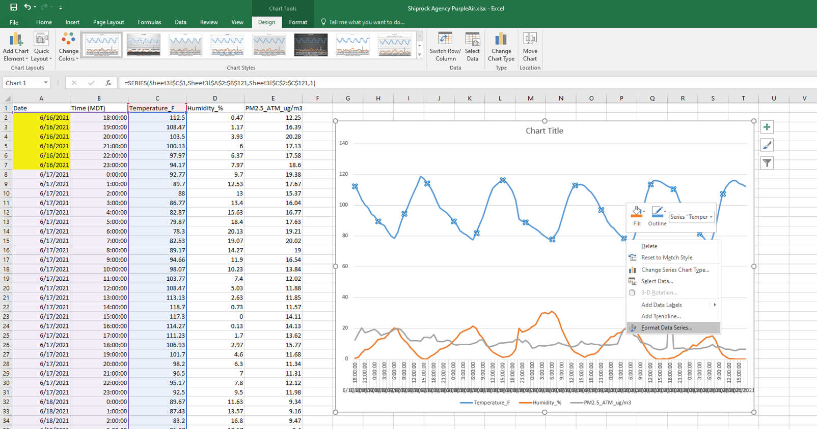

You will then select plot series on **Secondary Axis**.

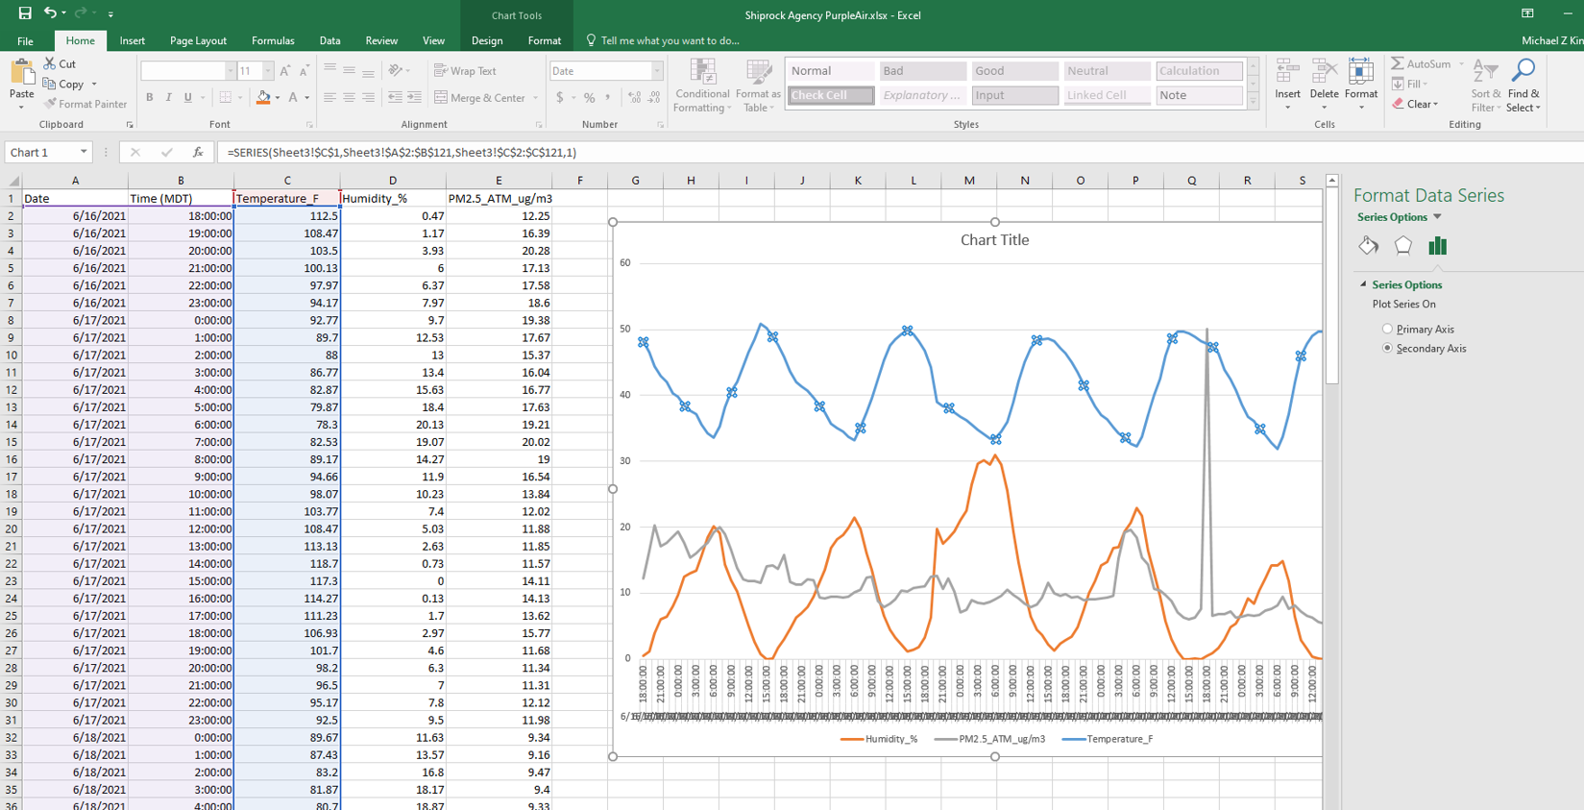

21. As you can see, the X-axis is cluttered and you cannot read the date and time. You can fix this by right clicking on the X-axis labels and select **Format Axis**.

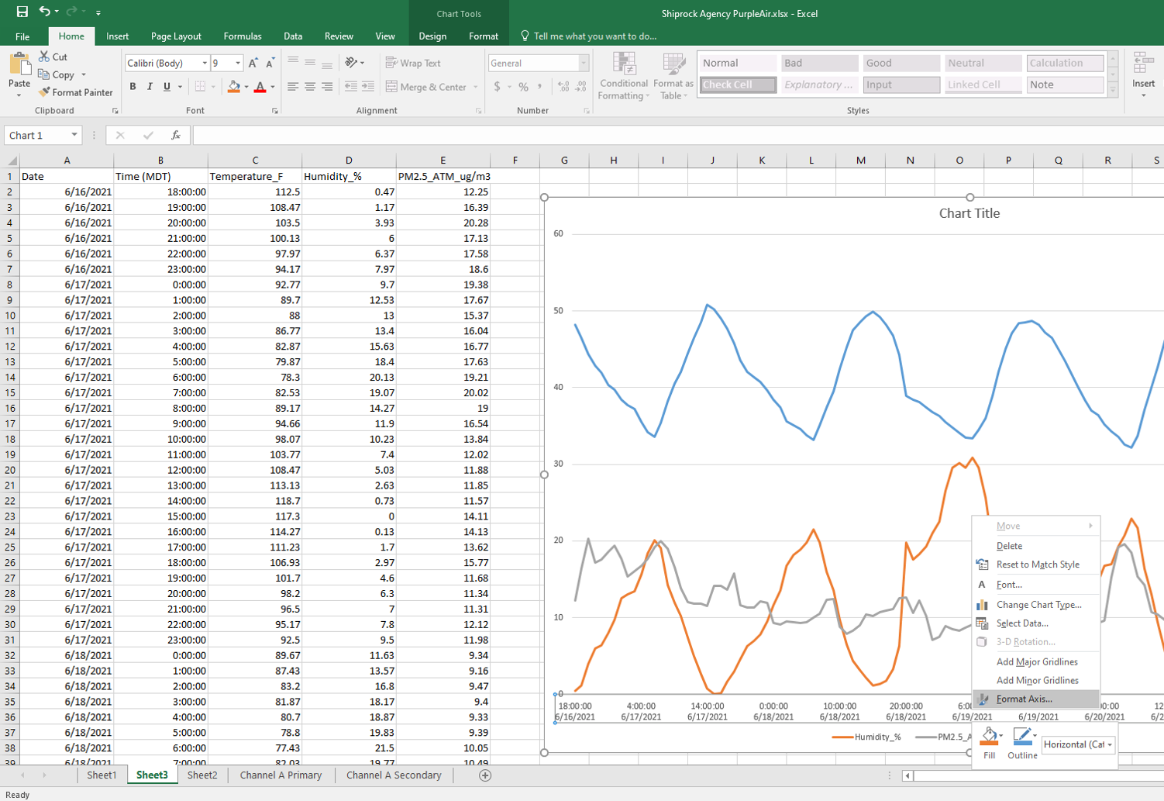

22. Within Format Axis under Axis Options, scroll down to Axis Type select **Text Axis**. Under Tick Marks scroll to Major Type set to **Outside**. Under Labels select **Specify Interval Unit** and set to **10**. Lastly, uncheck the box next to **Mult-level Category Labels**.

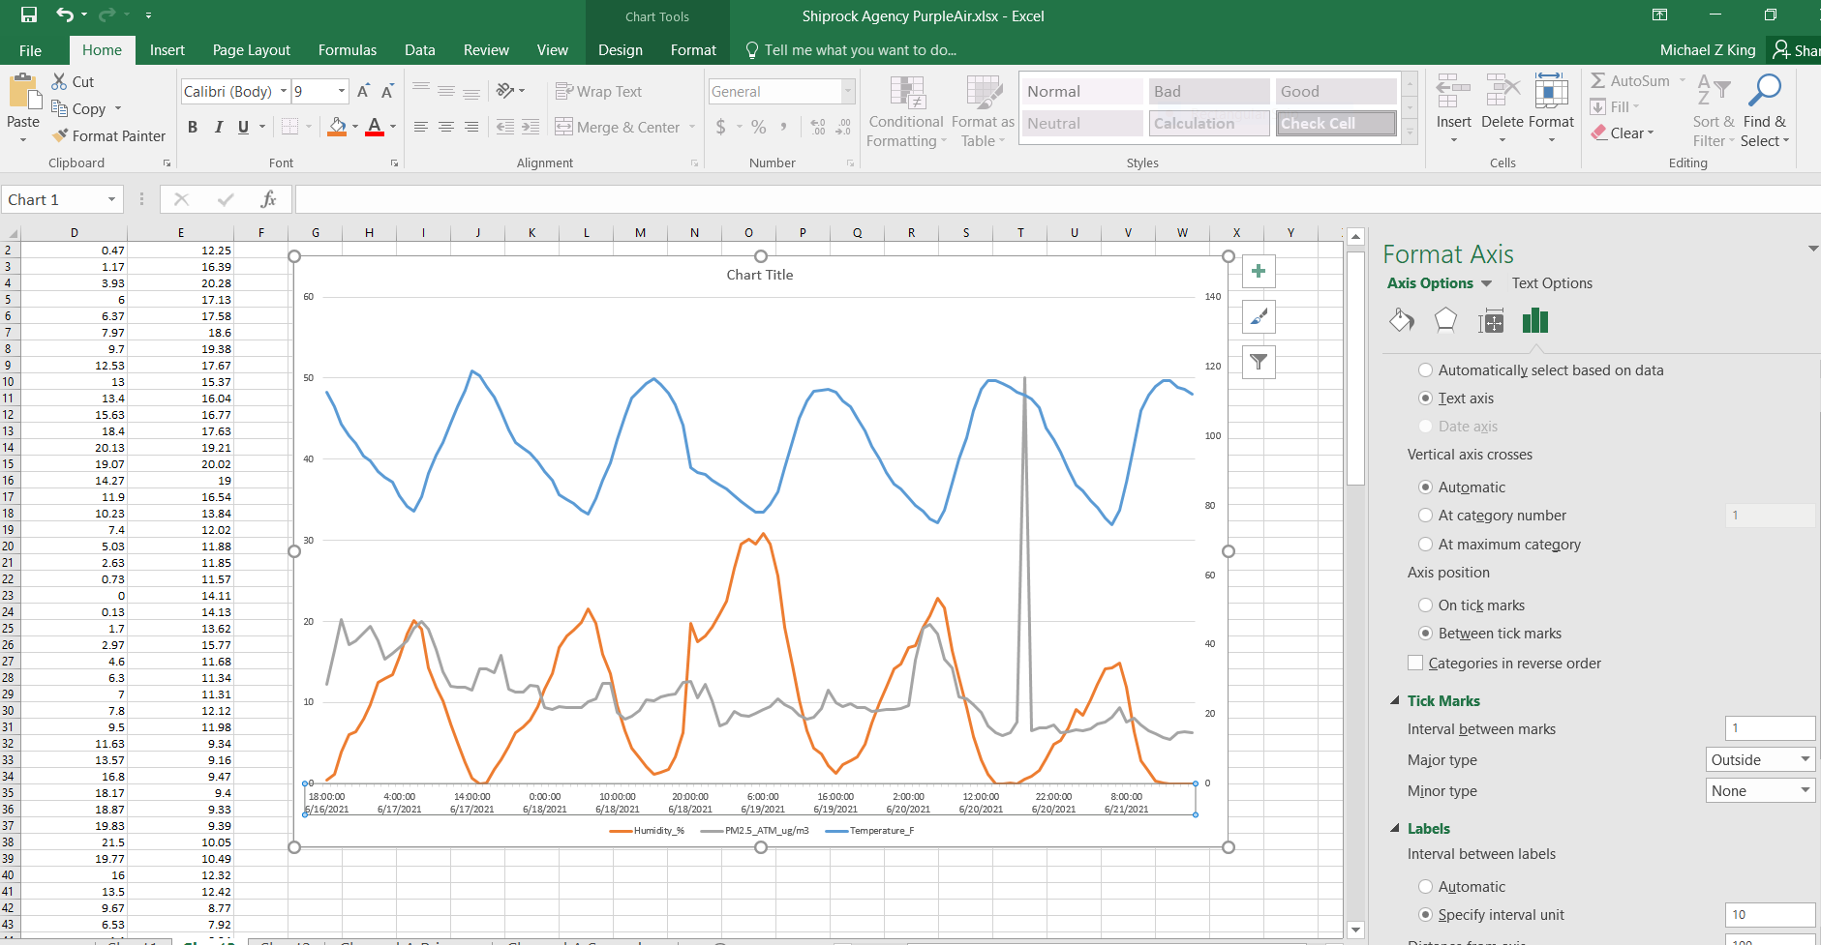

23. Click on Chart Title and add a Title to your chart. Your chart should now look similar to the chart below.

